BONNEVILLE DAM
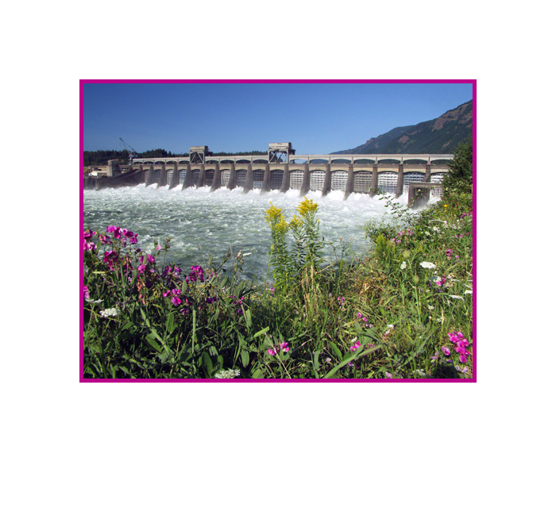
FISHWAY STATUS ANNUAL REPORT

2006

By

Ben J. Hausmann
Tammy M. Mackey
Jonathan G. Rerecich

U. S. Army Corps of Engineers
CENWP-OP-B
Bonneville Lock & Dam
Cascade Locks, OR 97014
(541) 374-4552

31 December 2006
TABLE OF CONTENTS

INTRODUCTION-----------------------------------------------------------------------------------2
Figure 1. Bonneville Lock and Dam--------------------------------------2

FISHWAY OPERATION AND ACTIVITIES----------------------------------------------3-6
Fish Passage Plan (FPP) Violations-----------------------------------------------3
Table 1. Fish passage plan violations and percent in criteria--------3
STS/VBS Inspections-------------------------------------------------------------------4
Table 2. STS and VBS Inspections 2005-2006-----------------------------4
Auxiliary Water System (AWS) Closures-----------------------------------------5
Table 3. Fish valve closures and closure times---------------------------5
Fish counts---------------------------------------------------------------------------------5
Adult Fishway Temperature Monitoring------------------------------------------6
Table 4. Average temperature in the Bradford Island fishway--------6
Table 5. Average temperature in the Washington Shore fishway----6
Table 6. Maximum temperature in the Adult Fish Facility--------------6
Table 7. Maximum temperature in the Adult Fish Facility--------------6
Zebra Mussels-----------------------------------------------------------------------------7
Avian Abatement Measures----------------------------------------------------------7
FISH FACILITY AND TURBINE OUTAGES-------------------------------------------7-10
Table 8. Fish Facility Outages & Maintenance-----------------------7
Table 9. Fish Unit Outages--------------------------------------------------8
Table 10 . Turbine Outages of at least 24 hours --------------------9

FISH REMOVAL-------------------------------------------------------------------------------9-10

RECENT FISHWAY MODIFICATIONS------------------------------------------------11-14

GLOSSARY----------------------------------------------------------------------------------------15

REFERENCES------------------------------------------------------------------------------------16

INTRODUCTION
The 2006 Fishway Status Annual Report for Bonneville Lock and Dam summarizes activities impacting fish at Bonneville from 1 December 2005 through 30 November 2006.

Primarily a summary of weekly reports, this document summarizes all activities affecting fish passage including maintenance outages, dewaterings and recent modifications to fishway components. This document is required by the Corps of Engineers’ Northwestern Division, as described in the Fish Passage Plan (FPP). The FPP contains the following surveillance and reporting requirements. “Project biologists shall inspect fish passage facilities at the frequencies listed in the juvenile and adult fish facilities operating criteria sections. The (weekly) reports shall include: any out of criteria situations observed and subsequent corrective actions taken; equipment malfunctions, breakdowns or damage, along with a summary of resulting repair activities; adult fish control calibrations; STS and VBS inspection; any unusual activities which occurred at the project which may affect fish passage.”

The Project includes two powerhouses, a spillway and two navigation locks. The older of the two navigation locks has not operated since early 1993. There are four adult fish ladders, for upstream migration, located at each powerhouse and the north and south ends of the spillway. There are three Juvenile Bypass Systems (JBS) for downstream migration: an Ice and Trash Sluiceway (ITS) at Powerhouse 1 (PH1), a downstream migration transportation channel (DSM) at Powerhouse Two (PH2), and the corner collector at PH2.

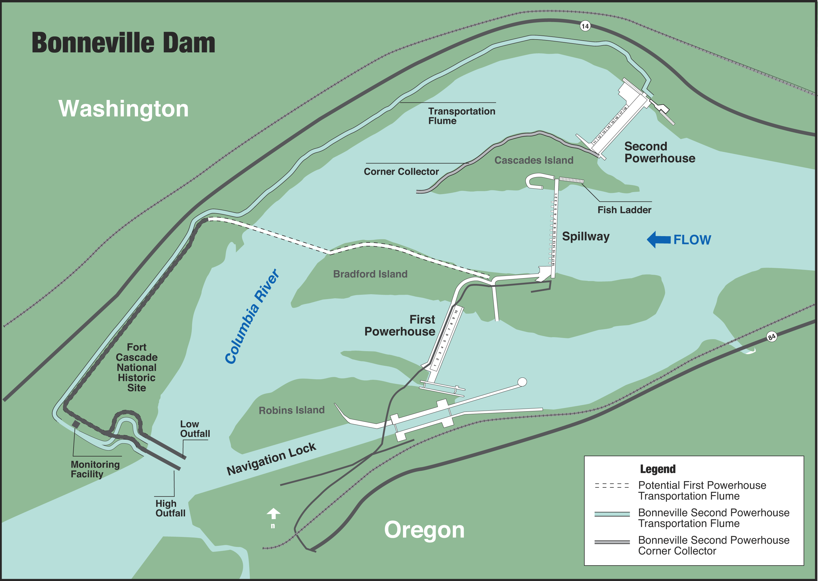
Figure 1 Bonneville Lock & Dam.

FISHWAY OPERATION AND ACTIVITIES
Fish Passage Plan Violations
The results of 320 daily fishway inspections, 7 conducted by National Oceanic and Atmospheric Administration (NOAA) Fisheries, or Fish Passage Center (FPC), are shown in the following table. Project Fisheries and the control room operators conduct inspections each day. Shown are the FPP violations and the percentage of days the item was in criteria. Items in criteria 100% of the time are not listed.

Table 1. Fish Passage Plan violations and percent in criteria.

The velocity meters were out of service or out of criteria most of the year. At PH1, the low velocities are due to an eddy in the slowest part of the collection channel. Due to this placement, Project Fisheries used the mechanical velocity meter as the primary indicator of velocity. At PH2, the meter had been improperly installed. Proper installation is scheduled for the winter of 06/07.
PH1 diffusers were out of criteria the entire fish passage season. FG2-19 and FG2-22A failed to open at water-up. The collection channel remained within FPP criteria however.

A-branch diffusers were out of criteria for most of the fish passage season as well. FG3-3 failed to operate in late summer. FG3-5 and FG3-6 also failed to operate correctly. All diffusers will be repaired during the winter of 2007/2008.

Orifices in the downstream migrant channel of Powerhouse 2 (DSM2) were out of criteria during late summer this year. We had a couple of orifice gates separate from the shafts. The manual orifices in Fish Unit 2 were opened to provide water, but the separated orifices reduced the ability of juveniles to exit the gatewell in a timely manner.

The DSM2 airburst system had a program malfunction for most of the season. Due to a program issue, the north end screens would work only intermittently. Electricians were finally able to correct the problem in late autumn. The project compensated for this by utilizing the mechanical screen cleaners.

Cascades Island diffuser FG6-12 had a bent shaft in the spring. FG6-11 was used to compensate when appropriate.

Weir 37 was out of criteria during early spring, late summer, and the fall. Water levels were over and under FPP criteria, usually no more than a couple tenths of a foot. AFF operations, fish (usually shad) blocking the weir drain, and increased aquatic debris loads were the primary causes for being out of criteria. Riggers and operators attempted to clean the trashrack whenever levels were more than 0.1’ out of criteria.

Weir 38 and 67 were out of criteria most frequently in the fall. When the UMT was closed to facilitate the VBS modifications in Units 16, 11, and 15, Washington Shore weirs started to read greater than 1.0’. Usually these two weirs were out of criteria by 0.1-0.2’.

STS/VBS Inspections
Submersible traveling screen (STS) and vertical barrier screen (VBS) are inspected once a month. Each STS has a timer that automatically shows elapsed time of operation, with one month of continuous operation equaling 720 hours. Bonneville uses an underwater video camera to inspect STSs and VBSs simultaneously, eliminating the need to dip gatewells.

Table 2. STS and VBS Inspections 2005-2006
Screens for PH1 were removed in December of 2005 and not re-installed this year. Current plans are to scrap all PH1 fish screens and modify the ice and trash sluiceway, in winter 2007/2008, to use as a juvenile bypass route.

Auxiliary Water System (AWS) Closures
The AWSs were closed on several occasions for varying reasons during the 2005-2006 reporting year. AWS valves were closed during winter maintenance, trashrack cleaning, remote operated vehicle (ROV) fishway inspections, oil leak in forebay, tribal truck removal, and fish salvage. Trashracks are usually cleaned multiple times each month with more frequent cleanings during fall and winter. FV 6-9 was closed to protect the WA shore fish ladder from oil which leaked from a truck that rolled into the forebay earlier in the year. The truck was located near the tribal fishing site upstream of the WA shore fishway exit. FV 4-3 and 4-4 were closed during the truck removal. FV 5-9 was closed during fish salvage operations prior to closure of the Cascades Is. fish ladder exit section. Table 3 shows the number of closures and average closure time per fish valve during each event.

Table 3. Fish Valve Closures and Closure Times. Closure times are averages where there is more than one closure event. All others are total closure times.
Fish Valves | Reason for closure | Number of closures | Closure time
FV 1-1 | Winter maintenance | 1 | 3 months 25 days
FV 3-7 | Winter maintenance | 1 | 3 months 26 days
FV 3-9 | Winter maintenance | 1 | 3 months 26 days
FV 4-3 | Winter maintenance | 1 | 3 months 26 days
FV 4-4 | Winter maintenance | 1 | 3 months 26 days
FV 1-1 | Trashrack cleaning | 14 | 9 hours 33 minutes
FV 3-7 | Trashrack cleaning | 11 | 5 hours 41 minutes
FV 3-9 | Trashrack cleaning | 12 | 4 hour 4 minutes
FV 4-3 | Trashrack cleaning | 1 | 42 minutes
FV 4-4 | Trashrack cleaning | 1 | 42 minutes
FV 5-3 | Trashrack cleaning | 2 | 15 minutes
FV 5-4 | Trashrack cleaning | 1 | 15 minutes
FV 5-9 | Trashrack cleaning | 7 | 25 minutes
FV 6-9 | Trashrack cleaning | 2 | 10 minutes
FV 1-1 | ROV | 1 | 3 hours 18 minutes
FV 3-7 | ROV | 1 | 3 hours 18 minutes
FV 3-9 | ROV | 1 | 2 hours 30 minutes
FV 4-3 | ROV | 1 | 2 hours 30 minutes
FV 4-4 | ROV | 1 | 2 hours 30 minutes
FV 5-3 | ROV | 2 | 2 hours 9 minutes
FV 5-4 | ROV | 2 | 2 hours 9 minutes
FV 5-9 | ROV | 2 | 2 hours 15 minutes
FV 6-9 | ROV | 2 | 5 hours 41 minutes
FV 6-9 | Oil response | 1 | 2 hours 12 minutes
FV 4-3 | Truck removal | 1 | 1 hour 3 minutes
FV 4-4 | Truck removal | 1 | 1 hour 3 minutes
FV 5-9 | Cascades Is. fish salvage | 1 | 19 hours 5 minutes

Fish counts
The Corps of Engineers contracts with the Washington Department of Fish and Wildlife (WDFW) for all fish counting. The fish count season is year round with visual counts from March until November and video counts during the rest of the year. All fish count numbers may be found at http://www.nwp.usace.army.mil/op/fishdata/home.asp

Adult Fishway Temperature Monitoring
Project biologists monitor fishway temperatures throughout the fish passage season, the AFF and SMF primarily during the summer months. The following temperature charts illustrate temperature trends. Detailed daily temperatures may be found in our weekly reports.

Table 4. Average Daily Temperature in the Bradford Island fishway.
Table 5. Average Daily Temperature in the Washington Shore fishway.
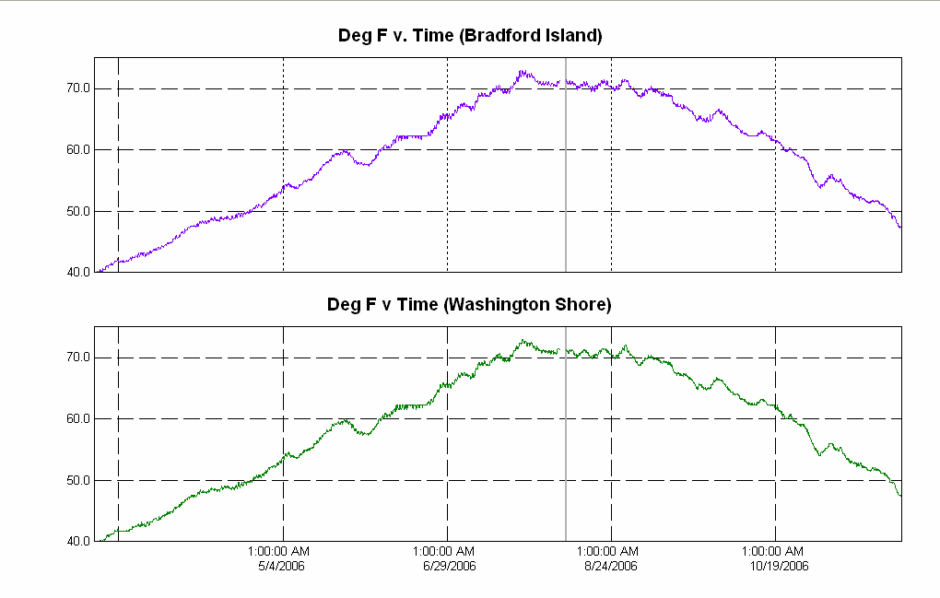

Table 6. Maximum Daily Temperature in the Adult Fish Facility (AFF).
Table 7. Maximum Daily Temperature in the Smolt Monitoring Facility (SMF).
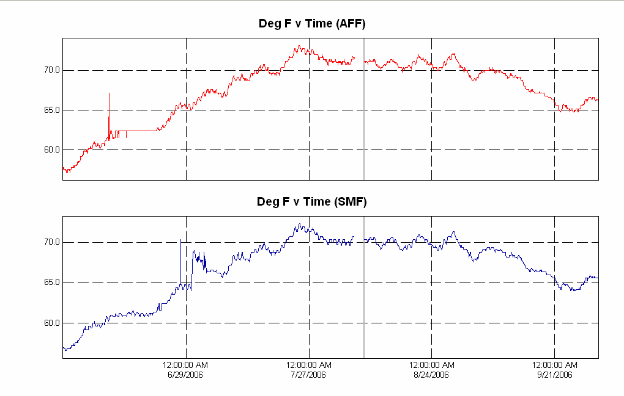

Zebra Mussels
Through weekly inspections of the monitoring station at the First Powerhouse and of all dewatered fishways, we have found no indication of zebra mussel colonization. It is understood that their arrival is inevitable. We continue monitoring with hopes that control programs can be initiated at the first indication of the zebra mussel’s arrival in the Pacific Northwest.

Avian Abatement Measures
Avian lines are strung at PH1 tailrace, spillway tailrace, PH2 tailrace, and over the B2 corner collector plunge pool. All lines were intact during the fish passage season. There were no additional avian hazing activities this reporting year.

FISH FACILITY AND TURBINE OUTAGES
Table 8. Fish Facility Outages & Maintenance
Fish Facility | Date Out | Date In | Reason for Outage
Bradford Island | 05 Dec 2005 | 25 Feb 2006 | Winter Maintenance
A and B branches | 05 Dec 2005 | 25 Feb 2006 | Winter Maintenance
B-branch (No AWS) | 22 Sep 2006 | 22 Sep 2006 | Sunken tribal truck salvage
BI Lamprey Ramp | 21 Nov 2006 | Present | Winter Maintenance
DSM1 | 21 Dec 2005 | NA | No longer used
Cascades Island exit | 07 Mar 2006 | 05 Oct 2006 | UMT closed for VBS modifications
UMT | 05 Oct 2006 | Present | VBS modifications to PH2 gatewells
AFF | 09 Jan 2006 | 01 Apr 2006 | Winter Maintenance
Washington Shore | 28 Feb 2006 | 28 Feb 2006 | Oil spill response
Washington Shore | 04 May 2006 | 04 May 2006 | Oil from sunken tribal truck
DSM2 | 20 Dec 2005 | 27 Feb 2006 | Winter Maintenance
DSM2 | 12 Apr 2006 | 12 Apr 2006 | ERG tripped due to high debris loads  clogging dewatering screens
DSM2 | 25 May 2006 | 25 May 2006 | ERG tripped due to high debris loads  clogging dewatering screens
DSM2 | 29 May 2006 | 29 May 2006 | ERG tripped due to high debris loads  clogging dewatering screens
DSM2 | 31 May 2006 | 31 May 2006 | Screen cleaner repair
SMF | 31 Oct 2006 | Present | System in bypass for winter
B2 Corner Collector | 31 Aug 2005 | 13 April 2006 | Winter maintenance
B2 Corner Collector | 03 Mar 2006 | 07 Mar 2006 | Spring Creek release
B2 Corner Collector | 31 Aug 2006 | 15 Nov 2006 | Opened to pass debris. Closed until 2007 fish passage season.
B2 Corner Collector | 21 Nov 2006 | Present | Closed until 2007 fish passage season

Fish Unit Outages and Reduced Loads

Table 9. Fish Unit Outages and Reduced Loads.
Dates - 2006 | Fish Unit 1
12 Jan | Out of Service(OOS) to float trash.
23 Jan – 01 Feb | OOS for annual overhaul.
02 Feb | OOS for floating orifice gate stab plate removal.
05 Feb | On standby to float trash.
14 Feb | OOS for remote operated vehicle fishway inspection.
10 Apr – 13 Apr | Reduced load for floating orifice gate removal and modification. Load was reduced only to allow for removal and fishways were returned to operating criteria once each gate was removed from the water.
17 Apr | Reduced load for floating orifice gate removal and modification. Load was reduced only to allow for removal and fishways were returned to operating criteria once each gate was removed from the water.
24 Apr | Reduced load for Sea Lion Exclusion Device removal.
28 Apr – 29 Apr | OOS due to governor oil leak.
01 May – 04 May | Reduced load during floating orifice gate repair for approximately one hour each day.
08 Aug | OOS for remote operated vehicle fishway inspection.
18 Aug | OOS for governor calibration and tuning.
14 Nov | On standby for gland water leak repairs.
Dates 2006 | Fish Unit 2
09 Jan – 18 Jan | OOS for annual overhaul.
02 Feb | OOS for floating orifice gate stab plate removal.
05 Feb | On standby to float trash.
14 Feb | OOS for remote operated vehicle fishway inspection.
10 Apr – 13 Apr | Reduced load for floating orifice gate removal and modification. Load was reduced only to allow for removal and fishways were returned to operating criteria once each gate was removed from the water.
17 Apr | Reduced load for floating orifice gate removal and modification. Load was reduced only to allow for removal and fishways were returned to operating criteria once each gate was removed from the water.
24 Apr | Reduced load for Sea Lion Exclusion Device removal.
29 Apr | On standby for repairs to Fish Unit 1.
01 May – 04 May | Reduced load during floating orifice gate repair for approximately one hour each day.
06 May | OOS due to governor problems.
08 Aug | OOS for remote operated vehicle fishway inspection.
21 Aug | OOS for governor calibration and tuning.
21 Oct – 23 Oct | OOS due to an exciter problem.

Fish units 1 and 2 were placed on standby at other times during the year to “float” trash away from the trash racks. When drawdown measured one foot or greater, fish units were shut down. An adjacent unit was then operated to pull trash away from the fish unit trashracks. This procedure helped prevent debris and silt from accumulating in front of the fish units. Most of the unit outages associated with the floating of trash and debris occurred between 2400 and 0300 to minimize impact on adult fish passage.

Table 10. Turbine Outages of at least 24 hours

Fish Removal
Fish passage facilities and turbine units are taken out of service and dewatered to allow for inspection, preventative maintenance, repairs, and modifications. As facilities and turbine units are dewatered, project biologists, outside agency personnel, and other project personnel follow procedures detailed in the Fish Salvage Plan to minimize impacts on fish. Recovered adult salmonids and lamprey are typically released into the forebay above the new navigation lock; sturgeon and juvenile salmonids are released below the dam at Hamilton Island.
The following is a summary of the number of fish removed during dewatering. All fish were recovered in good condition unless otherwise noted.
Bradford Island Fishway (12-05-2005): 158 O. mykiss, six chinook, two coho, 111 peamouth, 85 shad, 17 sucker, 15 whitefish, 13 lamprey, five northern pikeminnow, three smallmouth bass, and three carp.

DSM1 (12-21-2005): Six juvenile chinook, three juvenile steelhead, two bass, and one
sculpin.

Adult Fish Facility (1-09-2006): 18 adult steelhead, 10 juvenile steelhead, three juvenile chinook, one three spine stickleback, and one bass.

B-Branch (1-20-2006): five juvenile chinook, one juvenile steelhead, one adult unclipped steelhead, one sculpin, three dead adult unknown salmonids.

Unit 12 draft tube (1-26-2006): 15 yearling chinook, three stickleback, one sculpin, two carp.

Unit 11 Tail Logs (3-13-2006): 14 sturgeon, three sculpin, one bullhead, one bass

Cascades Island Exit section (3-22-2006): Three adult steelhead and two juvenile salmonids.

Unit 11 Tail Logs (3-30-2006): Two sturgeon.

Unit 12 Tail Logs (4-12-06): 16 sturgeon (five dead), two, catfish, one juvenile chinook, and one sculpin.

Unit 11 Draft tube (4-25-06): two clipped adult chinook, two juvenile chinook, one juvenile sockeye, one peamouth. One adult chinook died during transport.

Unit 11 tail logs (6-19-06): Nine sturgeon, two catfish, one sculpin, and one bass.

DSM2 add in (6-26-06): One adult chinook.

DSM2 add in (8-02-06): One clipped adult chinook.

Unit 13 Draft tube (8-22-06): four sturgeon, two catfish.

Unit 3 tail logs (9-11-06): three bluegill and six sculpin.

Unit 8 draft tube (9-13-06): seven catfish.

Tribal Truck Removal (9-22-06): three to five dozen crawdads.

Unit 16 draft tube (10-04-06): six sturgeon and seven catfish.

UMT (10-11-06): one adult unclipped coho, three adult shad, 50 juvenile shad.

Recent Fishway Modifications (1996-Winter 2006/07)
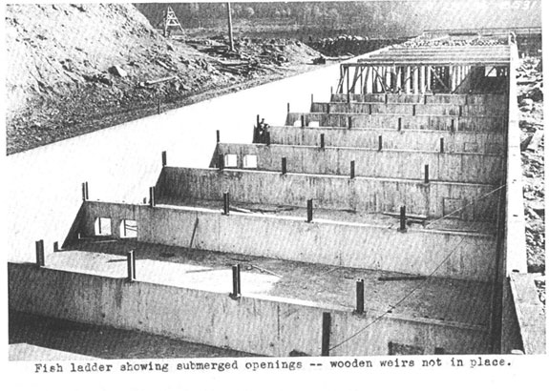Bradford Island fishway in 1933.

POWERHOUSE ONE ADULT
2004-present. Utilize ROVs for fishway inspections instead of divers.
2003/04. Installed new electronic velocity meter at the north end of the PH1 collection channel.

2005/06. Bulkheads were installed in the orifice gate and telescoping gate slots. Gates were removed along with the associated electronic and mechanical equipment.
2002/03. PH1 collection channel orifice gates and telescoping gates are closed and disabled. Studies indicated more fish exited these gates than entered. Weir gates were left in service.

2005/06. PIT tag detectors installed in four serpentine weirs in the Bradford Island fishway.
2001/02. Extra orifices in the overflow weirs were filled with concrete.
2000/01. PIT tag detectors installed in four orifice weirs in A-branch and four orifice weirs in
B-branch.
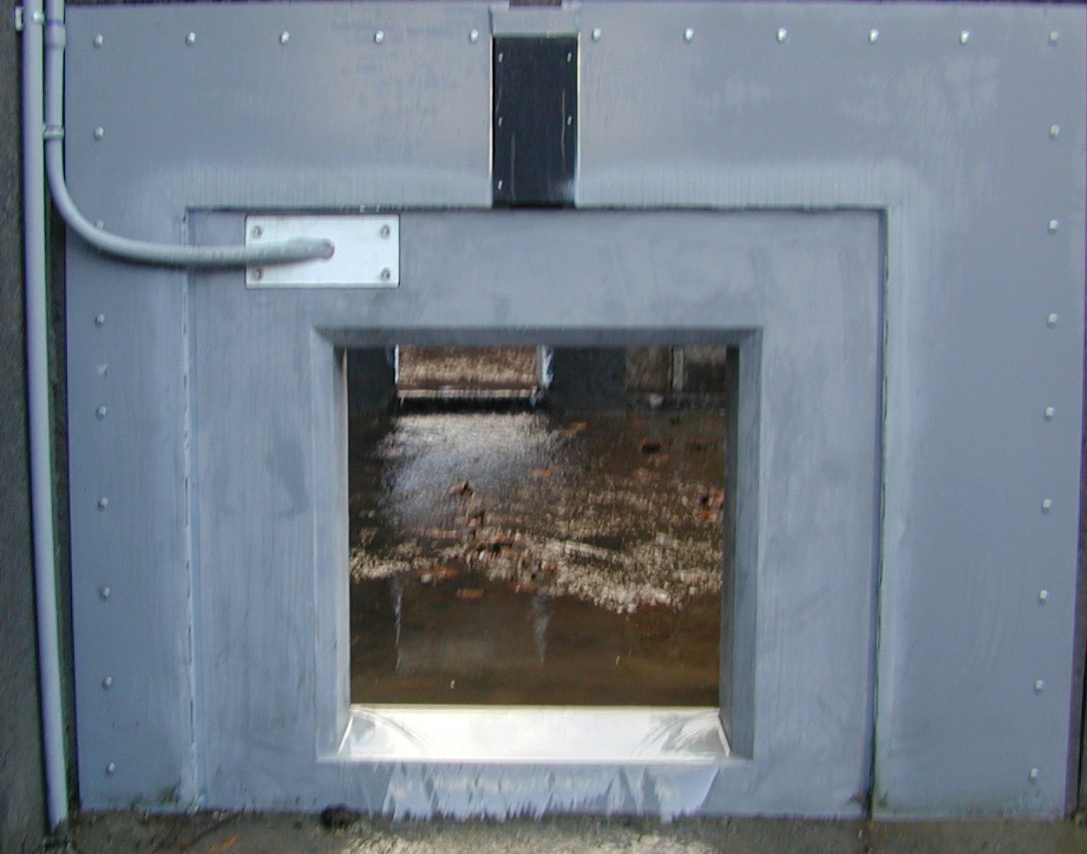 PIT tag detector and shield in an orifice.

1998/1999. FG3-10 through 17 disabled and filled with concrete. FG3-14 (at the junction pool) covered with metal plates instead of concrete.

POWERHOUSE ONE JUVENILE
2006/07. The south gate is broken. Screens are not installed in any PH1 units. The system is permanently out of service (screens are scrapped) until the Ice and Trash Sluiceway can be modified in 2007/08.
2004-2006. DSM1 is disabled as a juvenile bypass route. Screens are not installed during fish passage season except from 15 September until 15 December for adult fallback. The DSM is run south during this time.
2001/2003. Unit 8 ESBSs were deemed undesirable and replaced with standard STSs.

2000-present. Turbine rehab involves installing minimum gap runners on all PH1 main units. Roughly one unit is completed each year. Units 1-6 are completed. Units 8 and 10 will be finished in 2007. Units 7 and 9 will be done after Unit 8 has returned to service.
2001-present. The 2000 BiOp required the removal of impediments to fish passage from the turbine environments. Removal and replacement of excess metal, with fish friendly alternatives, occurs as units go out of service for rehab.
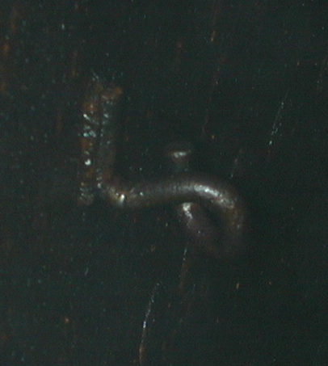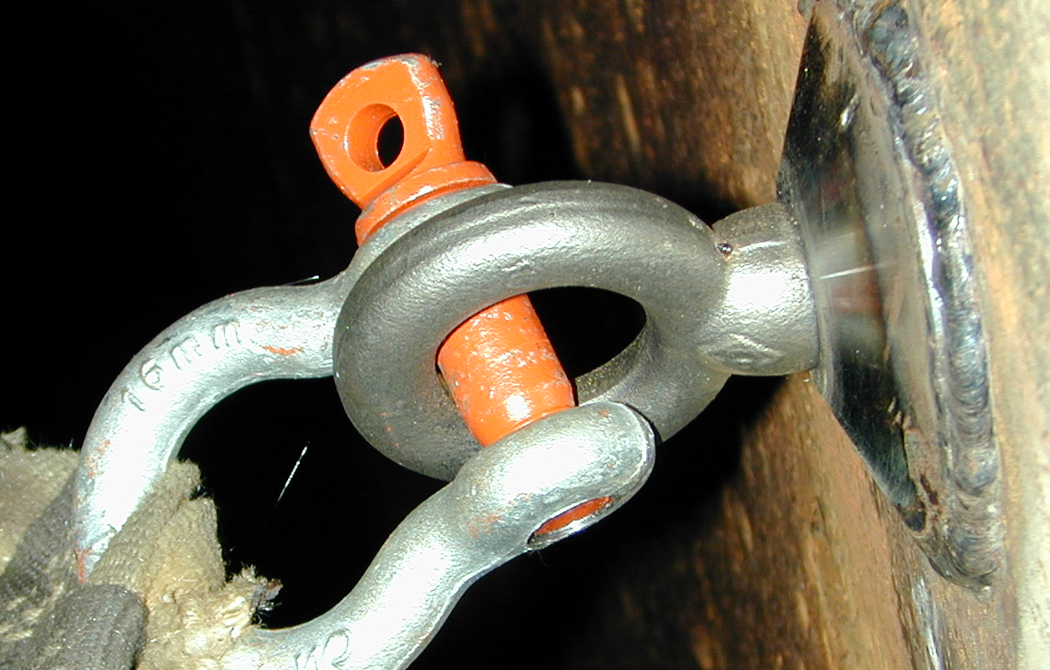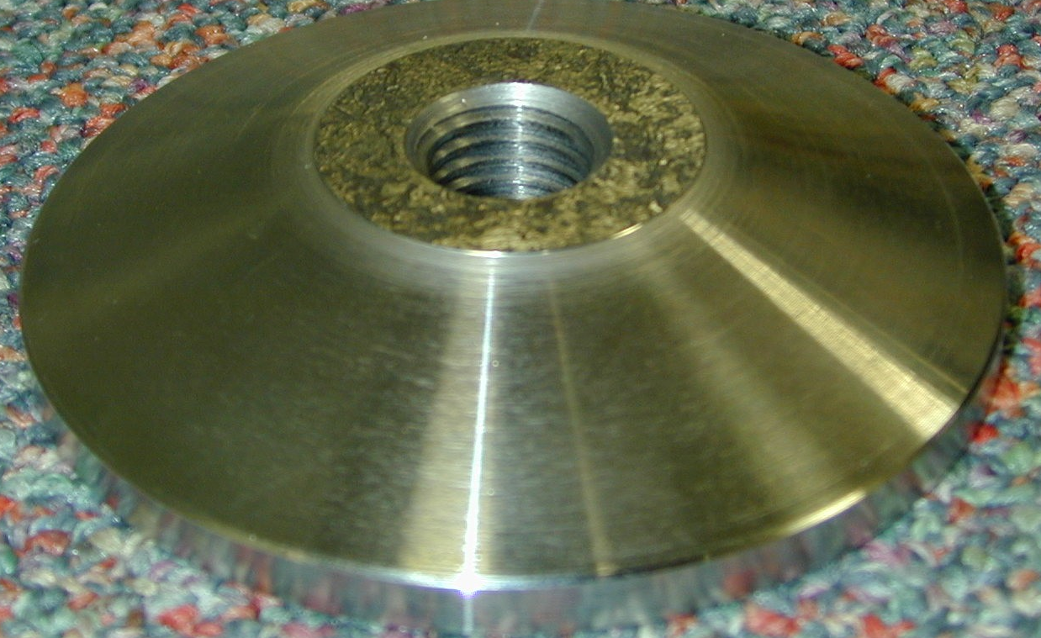
Old safety net hook. New safety net hook system. New draft tube pucks.

POWERHOUSE ONE LAMPREY
2005/06. PIT tag detection and expanded lamprey ramp installed in the Bradford Island FV3-9 AWS channel.
2003/04. Lamprey ramp installed in the Bradford Island FV3-9 AWS channel.
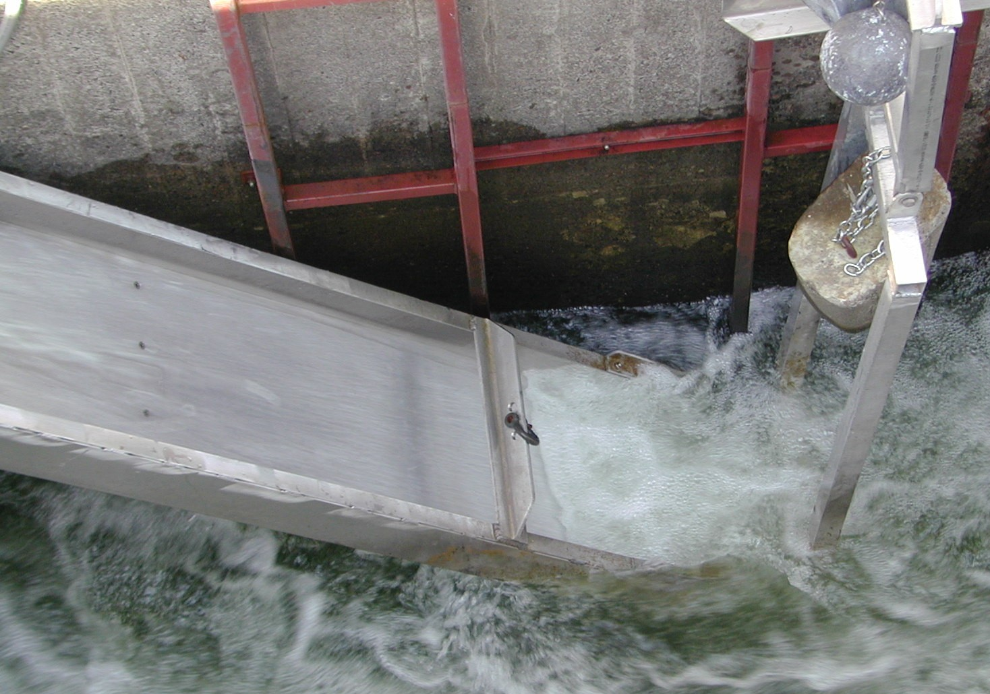 Lamprey ramp in the FV3-9 AWS channel.

CASCADES ISLAND FISHWAY/ UMT
2004-present. Utilize ROVs for fishway inspections instead of divers.
2001/02. New diffuser covers built and installed.
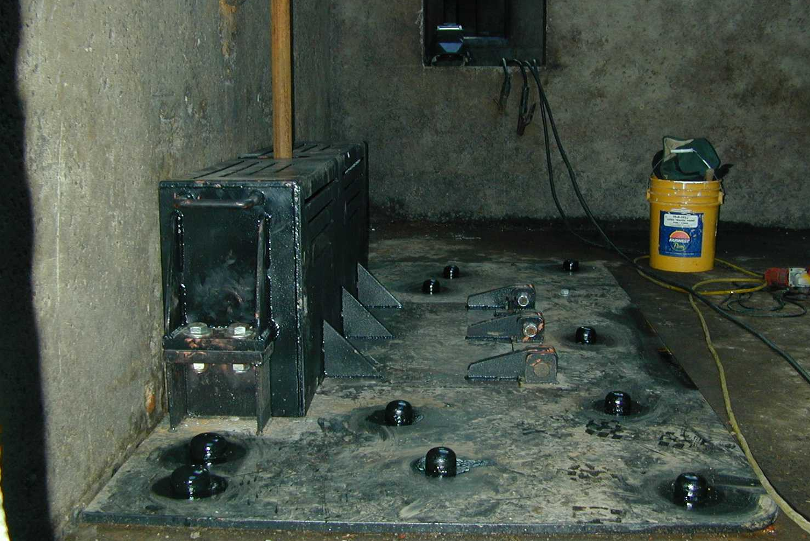 New diffuser covers for main dam fishways.
2000/01. More PIT tag detectors installed in four orifice weirs.
1999/2000. FG6-1 through 4 filled in with concrete.
1998/1999. PIT tag detectors installed in four orifice weirs.

2004/05. UMT fish count window crowder and window cleaner removed.
1996-2000. The UMT drain is blind flanged and no longer used.

CASCADES ISLAND LAMPREY
2005/06. Half duplex PIT tag detectors were installed along the picket leads to track lamprey.

POWERHOUSE TWO ADULT
2006/07. Installed new staff gauges in the monoliths.
2004-present. Utilize ROVs for fishway inspections instead of divers.
2004/05. Repaired the AWS conduit.
2004/05. Installed new velocity meter at SUE.
2003/04. Picket leads for the triangle section were removed.
2002/03. Removed old metal staff gauge frames from monolith entrances.

2004/05. PIT tag detectors installed in four serpentine weirs.
2001/02. PIT tag detectors installed in eight orifice weirs, four upstream and four downstream of the AFF.

2006/07. AFF lamprey orifice gate removed due to pulley failure resulting in salmon passage blockage and dewatering difficulties.
2005/06. AFF count window crowder removed due to structural failure.
2004/05. AFF brail pool modifications made. The brail pool is now the primary recovery pool.
2003/04. AFF electrical upgrades complete.
1999/2000. AFF exit ladder equipped with orifice PIT tag detectors.

POWERHOUSE TWO JUVENILE
2006/07. New LED lights replace the halogen lights. The LED lights are cooler and will last years longer than the halogens. These lights were salvaged from DSM1.
2002/2003. NMFS fyke net frame is removed from the tailrace.
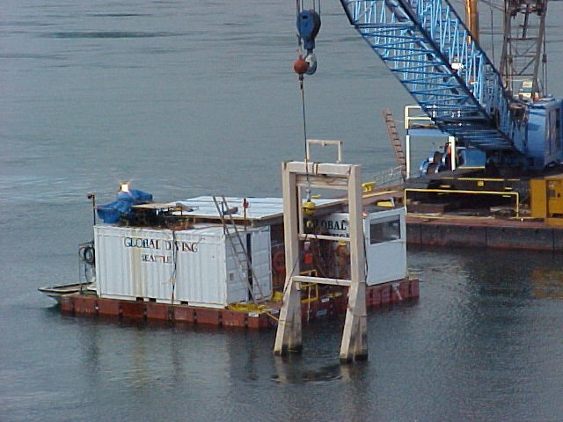 Fyke net frame removal from PH2 tailrace.

2001/02. Raised the DSM2 walkway grating to prevent fish from impacting it.
2001/02. Modified the DSM2 add-in screen to vertical bars to allow juveniles to move out of the add-in water and into the channel. The bars didn’t reach the walkway so a perforated plate was added later in the season to prevent adults from jumping into the add-in section.

2005/06. B2CC PIT tag antenna installed.
2004/05. B2 Corner collector complete and online.
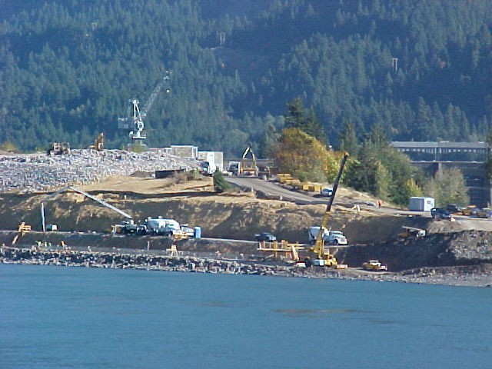 Construction of the B2 corner collector.

2006/07. Units 11, 15, 16 are modified for new VBSs and improved fish guidance efficiency (FGE).
2005/06. Units 12 and 13 are modified for new VBSs and improved FGE.
2004/05. VBS modifications for Unit 17 result in screen failure. The design for the new VBSs is re-examined and redrawn.
2003/04. Unit 17 VBSs and gatewells are modified to improve FGE. Modifications include gap closure devices on the STSs and modified VBSs.
2002/03. Unit 15 gatewells are partially modified to improve FGE. Modifications include gap closure devices on the STSs.
2002-present. The 2000 BiOp required the removal of impediments to fish passage from the turbine environments. Removal and replacement of excess metal, with fish friendly alternatives, occurs as units come out of service for maintenance.

2005/06. SMF full flow PIT tag antenna installed.
2004/05. Outfall hydrocannon piping is replaced.
2002/03. Biologists notice the two mile pipe is starting to go out of round. The pipe has been surveyed every year since the issue was discovered.
2000/01. Saltwater rearing moved into the SMF.
2001/02. Flume covers were added over the switchgates. This was to encourage fish to stay in the main channel and not seek shade by swimming under the switchgates.
2000/01. Modifications were made to the primary dewatering structure drain pipe to divert more water into the wetlands. This reduced the flow fluctuations and air bubbles under the perforated plate in the primary dewatering structure.
1998-2000. SMF construction completed. The facility goes online.

POWERHOUSE TWO LAMPREY
2004/05. Lamprey ramp installed at NDE.
2000/01. Lamprey plates are installed over the Washington Shore diffuser grates.
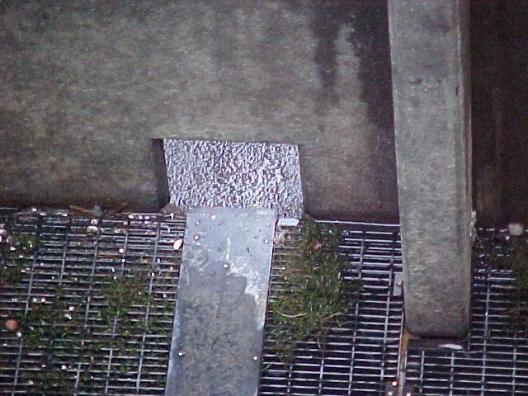
Lamprey plates in Washington Shore.

navigation locks
2002. The old navigation lock is seined for fish and the miter gates are closed.

BASS LAKE
2006. The leaking drain is repaired. The lake holds water and coho are seen spawning in the outlet (Moffett Creek) of Bass Lake. The salvaged logs create log jams over the sink hole.
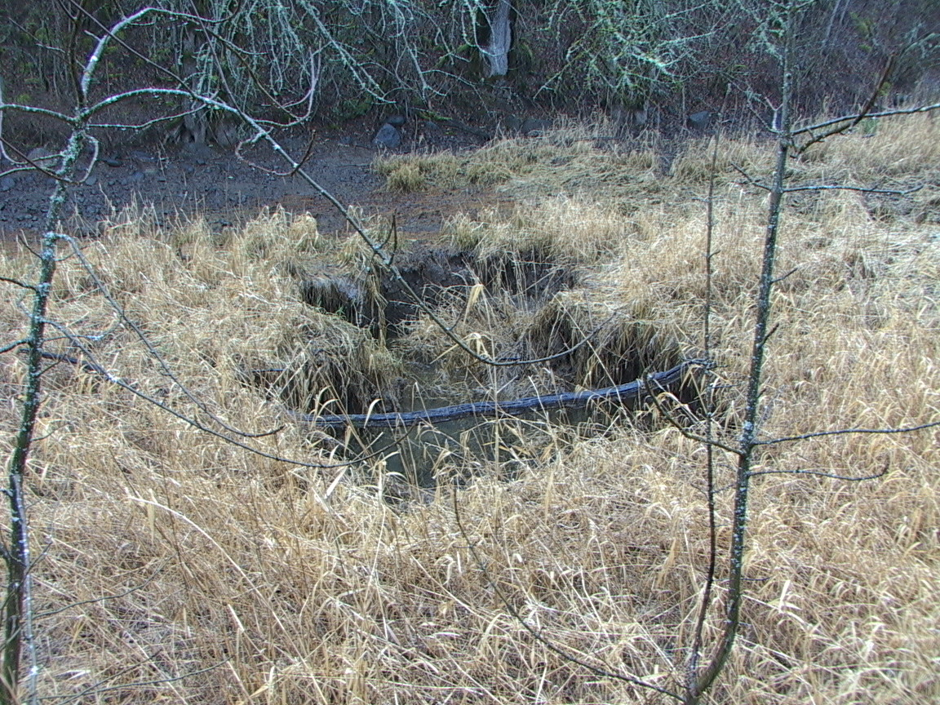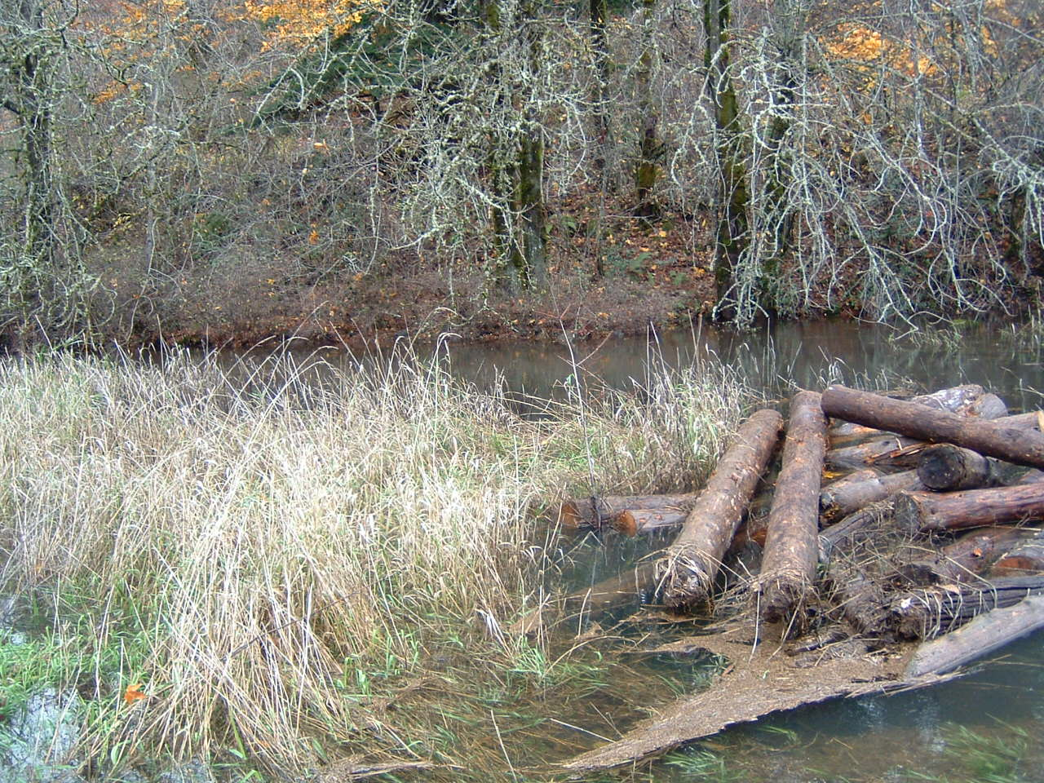
Sink hole in 2005 Sink hole in 2006
2004. Salvaged logs are placed in Bass Lake to provide habitat.
GLOSSARY
AFF----- Adult Fish Facility. Lab associated with the Washington Shore ladder. Adult fish are trapped for research purposes.
AWS-------------------------Auxiliary Water Supply.
B2CC---- Powerhouse Two Corner Collector. A surface bypass system located in the southern corner of the Bonneville Second Powerhouse forebay.
BiOp Biological Opinion.
BON Bonneville Lock & Dam.
Downwell Opening through which water and fish drop after excess water is drawn away through a dewatering screen. Start of the transport conduit for fish from DSM1 to the tailrace.
DSM 1-- Downstream Migrant transportation channel (PH1). Transport channel for juvenile fish from gatewell orifices to the downwell.
DSM 2-- Downstream Migrant transportation channel (PH2). Transport channel for juvenile fish from gatewell orifices to the juvenile transport pipe.
CRITFC Columbia River Intertribal Fish Commission.
FFU----- Fisheries Field Unit. Unit in the Corps of Engineers’ Portland District Construction, Operations Division that conducts fish related evaluations and monitoring.
FGE--------------------------Fish Guidance Efficiency.
Forebay That area of a reservoir immediately upstream of a dam.
FPC Fish Passage Center.
FPP Fish Passage Plan.
HSS--------------------------Hydraulic Steel Structures.
ITS Ice and Trash Sluiceway.
JBS Juvenile Fish Bypass System.
Kcfs Thousand cubic feet per second.
NDE----- North Downstream Entrance. Refers to one of the four large overflow weir adult fishway entrances at PH2.
NUE North Upstream Entrance. See NDE.
NOAA Fish National Oceanic and Atmospheric Administration Fisheries (NMFS).
ODFW Oregon Department of Fish & Wildlife
OOS Out Of Service.
PCC----- Powerhouse Collection Channel. Part of the adult fishway spanning the length of the downstream side of each powerhouse.
PH1 Bonneville Powerhouse One.
PH2 Bonneville Powerhouse Two.
PIT ------ Passive Integrated Transponder. A tag inserted into juvenile and adult fish. Detectors are installed at all fish passage systems.
Project Bonneville Lock & Dam.
ROV--------------------------Remotely Operated Vehicle.
SDE South Downstream Entrance. See NDE.
SMF Smolt Monitoring Facility. Lab associated with the PH2 JBS.
SUE South Upstream Entrance. See NDE.
STS Submersible Traveling Screen.
Tailwater The portion of a river immediately downstream of a dam or powerhouse.
TIES Turbine Intake Extension Screen.
Tule Early spawning fall chinook.
UMT----- Upstream Migrant Transportation channel. This channel connects Cascades Island ladder to Washington Shore ladder through PH2.
VBS Vertical Barrier Screen.
WDFW Washington Department of Fish & Wildlife.

REFERENCES

2005. Fish Passage Plan for Corps of Engineers Projects. U. S. Army Corps of Engineers, Northwestern Division, Portland, Oregon.

2006. Fish Passage Plan for Corps of Engineers Projects. U. S. Army Corps of Engineers, Northwestern Division, Portland, Oregon.

2005-2006. Weekly reports for Bonneville Dam. U.S. Army Corps of Engineers, Portland District. Bonneville Lock and Dam.

2005-2006. Daily fishway inspections for Bonneville Dam.

